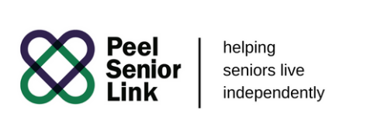

|  |  |  |  |
| --- | --- | --- | --- |
| **Job Title:** | **Personal Support Worker** | | |
| **Department/Group:** | Operations | **Position Type (FT, PT, Relief, etc.):** | Full Time/Part Time/Relief |
| **Location:** | Peel Senior Link Mississauga/ Brampton Sites | **Level/Salary Range:** | $19.50 per hour |
| **Contact Person: Gunaliny Ravikumar**  **Email: guna@peelseniorlink.com**  **Fax : 905-712-3373** | | **Mailing Address: 50 Burnhamthorpe Rd West, Mississauga, ON L5B 3C2** | |
| **Job Details** | | | |
| **Organization Overview:** Peel Senior Link, a non-profit charitable organization established in 1991, provides personal care & home-making services. Peel Senior Link maximizes independent living--helping seniors live with dignity, stability and safety. Peel Senior Link is funded by the Ministry of Health and Long-Term Care through the Mississauga Halton Local Health Integrated Network and the Central West Local Health Integrated Network, grants and personal and corporate donations.  **Job Summary:** The Personal Support Worker provides personal care and daily support to clients in their own home. Performs light housekeeping duties and works closely with supervisors, clients, and other members of the Peel Senior Link team to help seniors maintain their independence and dignity.  **Duties/Responsibilities:**   * Administers personal care to clients, e.g. bathing, grooming, toileting, dressing and applying pressure stockings, where applicable, etc. * Maintains client health and well-being by assisting with: medication monitoring and administration. * Assists in meal preparation, e.g. cutting up fruits/vegetables, heating up food, and accommodating specific dietary needs. Feed clients that are unable to do so. * Performs general housekeeping duties as required. * Interacts with clients and provides social/emotional support. * Conducts safety checks of client’s homes and advises supervisor of potential health or safety concerns; handles medical emergencies. * Communicates both verbally and written with supervisor, co-workers and community partners. * Acts as intermediary between supervisor, clients and the client’s family and documents any changes in client behaviour. * Handles office duties as required, these duties include: photocopying, faxing, answering phones and taking messages. * Performs one person transfers using designated tools, e.g. Hoyer lift. * Performs other tasks as directed by supervisor/clients.   **Requirements**   * Access to a vehicle with valid Ontario Drivers License and Car Insurance * PSW Certificate * Valid First Aid & CPR Certification * Clear Police Record Check & Vulnerable Sector Check (completed in the last 6 months) | | | |



1